**JavaScript: Basic Concepts Lab Work**

1. Where is the correct place to insert a JavaScript in the HTML page?

<body> </body> tag

1. Write JavaScript syntax to change the content of the below HTML element.

<p id="demo">This is a demonstration.</p>

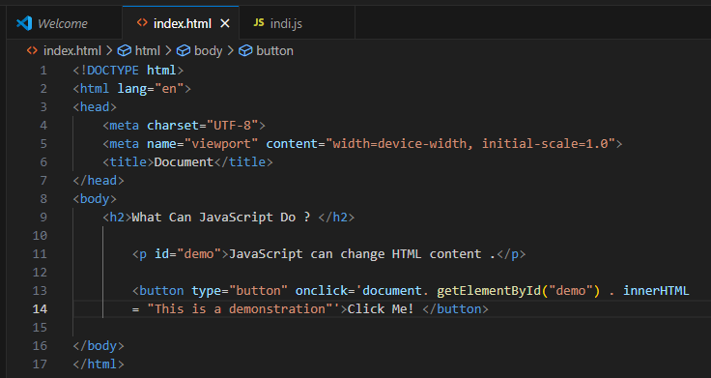

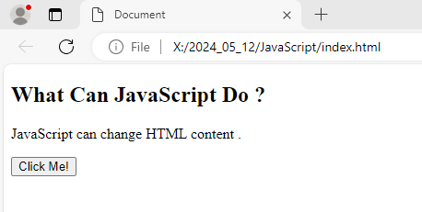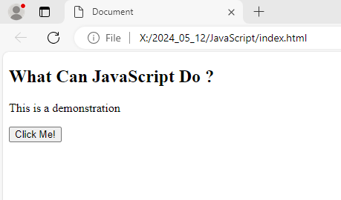

1. Create a variable called carName, assign the value Volvo to it.

<script>

        var carName = "volvo";

          document.getElementById("demo").innerHTML=carName;

      </script>

1. Write the correct syntax for referring to an external script called "xxx.js"

<script src="xxx.js"></script>

1. Write the correct syntax to display “Hello World” in an alert box?

<button type="button" onclick="myfile()"> Hello</button>

function myfile(){

  alert("Hello world");

  }

1. Write the correct syntax to create a function in JavaScript?

Function myhtml(){}

1. What is the correct syntax for a single-line comment in JavaScript?

// single-line comment

1. Display the sum of 5 + 10 in HTML page, using two variables: x and y.

var x = 5;

var y =10;

console.log(x+y);

1. Create a variable called z, assign x + y to it, and display the result in an alert box.

  var x = 5;

      var y =10;

     var z= x+ y;

          document.getElementById("demo").innerHTML=alert(z);

1. On one single line, declare three variables with the following names and values

firstName = "John"  
lastName = "Doe"  
age = 35

<p id="demo"></p>

<script>

const firstName="john";

    const lastName="Doe";

    const age= 35;

let result = firstName.concat(lastName,age);

document.getElementById("demo").innerHTML = result;

</script>

1. Write JavaScript code to multiply 10 with 5, and alert the result.

<button type="button" onclick="my11()"> calculate</button>

function my11(){

alert(5*10);}

1. Write JavaScript program to divide 10 by 2, and alert the result.

<button type="button" onclick="my12()"> calculate</button>

1. What is the result of the following expression?

5 + 5 + "5"



1. Write JavaScript program to alert the **remainder** when 15 is divided by 9.

<p>y = 5<br>calculate x = y % 2:</p>

    <p id="demo"></p>

<script>

  let y = 5;

        let x = y % 2;

      document.getElementById("demo").innerHTML = "Value of x is: " + x;

    </script>

1. What will the following code output?

console.log(2 + "2");



1. What will the following code snippet output?

console.log("5" - 3);



1. What will the following code snippet output?

console.log("Hello" + 1 + 2);



1. Write a JavaScript program to reverse the order of characters in the string.

 function reverseLetter(str){

    return str.split("").reverse("").join("");

}

1. Write a JavaScript function to return the sum of a and b.

<h1 id="check"></h1>

<script>

  document.getElementById("check").innerHTML=checkss(10,10);

  function checkss(a,b){

      return (a+b);

  }

</script>

1. Write a JavaScript function that takes an integer minutes and converts it to seconds.

function toSeconds(str) {

  var pieces = str.split(":");

    var result = Number(pieces[0]) * 60 + Number(pieces[1]);

    return(result.toFixed(3));

}

console.log(toSeconds("1:29.460"));

1. Write a function that takes the base and height of a triangle and return its area.

const baseValue = prompt('Enter the base of a triangle: ');

const heightValue = prompt('Enter the height of a triangle: ');

// calculate the area

const areaValue = (baseValue * heightValue) / 2;

console.log( `The area of the triangle is ${areaValue}` );

1. Create a function that takes the age in years and returns the age in days.

const areaValue = (18 * 364) ;

1. Create a function that takes length and width and finds the perimeter of a rectangle.

<h1 id="check"></h1>

<script>

    document.getElementById("check").innerHTML=checkss(10,10);

    function checkss(lenth,width){

        return (lenth+width)*2

    }

</script>

1. What will be the output of the following code snippet?

let name = ”Unicom TIC”;

console.log(name.charAt(4));

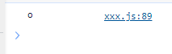

1. Write a JavaScript program to reverse each word in the given sentence?

For example “Welcome to this Javascript Program!”

should be become “emocleW ot siht tpircsavaJ !amrgorP”

const original="welcome to this javascript program!";

const home = original.split(" ").reverse().join(" ");

console.log(home);

const reverse=reverseLetter(home);

console.log(reverse);